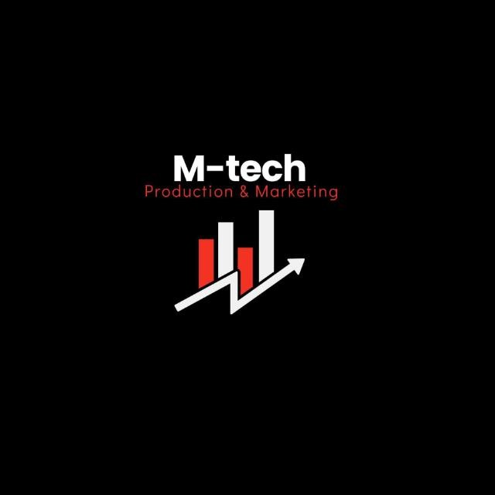

M-Tech Production & Marketing
Technology | Training | Marketing | Projects
TASK 11 REPORT
Internship Program — Batch 2026

Submitted By:
Hamza Badshah / Mtech-AI26028

Department:
AI / ML
Submitted To:
Ma’am Fatima

_______________________ | Supervisor:

Date:
15 July 2026

Haripur Main Bazar, Khyber Pakhtunkhwa, Pakistan
mtechproductionandmarketing@gmail.com | +92 336 2222480

Introduction

This report presents the work completed for Task 11 of the M-Tech Production & Marketing AI/ML Internship Program, Batch 2026. The internship focuses on practical exposure to core concepts in Artificial Intelligence and Machine Learning, equipping interns with skills applicable to real-world technology and marketing challenges.

M-Tech Production & Marketing is a forward-looking company based in Haripur, KPK, specializing in Technology, Training, Marketing, and Projects. The internship is structured in a 9-Phase roadmap designed to progressively build theoretical knowledge and hands-on project experience.

Objectives

- Understand the limitations of traditional recurrent architectures and the advantages of the self-attention mechanism.
- Analyze the Transformer architecture, specifically the encoder-decoder structure and positional encoding.
- Implement BERT to perform downstream NLP tasks such as sentiment analysis or text classification.
- Learn to leverage pre-trained models to achieve high accuracy with limited local training data.

Task Description

The task involves setting up a language processing pipeline to handle text data. This includes tokenization, converting text into numerical embeddings, and feeding these sequences into a pre-trained BERT model. The primary goal is to fine-tune the model to understand the nuance of input text, demonstrating the capability to apply large-scale language models to specific, real-world marketing or technical communication challenges.

Work Done

- Text Pre-processing: Implemented industry-standard tokenization techniques, utilizing WordPiece tokenization to prepare raw text for the Transformer model.
- Transformer Analysis: Examined the self-attention mechanism, observing how it allows the model to weight the significance of different words in a sentence relative to one another, regardless of their position.
- Model Implementation: Loaded a pre-trained BERT model and fine-tuned it on a custom dataset to perform classification. This involved freezing certain base layers and training the classifier head to adapt the model to the specific task.
- Performance Benchmarking: Evaluated the model’s performance using metrics such as Precision, Recall, and F1-Score, and compared the efficiency of fine-tuning versus training a model from scratch.

Challenges Faced

- Resource Constraints: BERT models are computationally expensive. Initial implementation required significant memory optimization and the use of smaller batch sizes to prevent out-of-memory errors on local hardware.
- Tokenization Complexity: Managing the vocabulary size and ensuring that the input sequences were properly truncated and padded to meet the model's fixed input constraints was technically demanding.
- Hyperparameter Tuning: Fine-tuning a Transformer requires careful selection of learning rates and scheduling; improper settings led to "catastrophic forgetting," where the model lost its pre-trained linguistic knowledge.

Key Learnings

- The "bidirectional" nature of BERT allows it to capture context from both the left and right sides of a token simultaneously, which is significantly more effective for understanding language nuances than previous unidirectional models.
- Transfer learning is the cornerstone of modern AI; utilizing pre-trained architectures like BERT allows for high-performance applications in technology and marketing without requiring massive custom datasets.
- Attention is the most critical innovation in recent NLP, enabling models to handle long-range dependencies in text that were previously impossible to model effectively.

Conclusion

Experiment 11 successfully demonstrated the power of Transformer architecture. By transitioning from basic machine learning to state-of-the-art NLP models like BERT, I have developed the ability to deploy intelligent systems capable of parsing, understanding, and generating human language. These skills are directly applicable to the diverse technology and training projects managed at M-Tech Production & Marketing.

Intern Signature: | __Hamza Badshah __ | Supervisor: | _______________________
Name: | Hamza Badshah | Name:
Date: | 15 July 2026 | Designation:

